

Design Document

PROCP Project





Team members:   
Kaloyan Dragiev - 3214311  
Yanis Dimov - 3258033  
Nikolay Nikolaev - 3235106  
Rosen Panayotov - 3334643  
Nikolay Kolev - 3235106

**Table of content**

**Introduction** 3

**Context** 3

**MOSCOW** 3

**GUI** 5

**Milestones** 5

**Timeline** 6

# **Introduction**

In this document we will list and explain all features in a table and show their importance, display design pictures of the simulation application and outline the milestones of the project phases. In addition, we will give a brief description of the context of the project and what is expected from us. Nevertheless, this document focuses mainly on the second part of the overall project (implantation and design of software solution).

# **Context**

Аs a second year students we already have basic knowledge of programming, putting ideas into documents and managing it properly. In the long run in our future career we will more or less face some challenges and even have more tension at the real work environment. The idea of that kind of project is to make students feel and examine how things are settled down outside university and be prepared. Tutor helps us and gives us direction how we should proceed with the project.

# **MOSCOW**

The following table shows the requirements of the software solution and classifies them by taking into account their relevance.

|  |  |  |  |  |  |
| --- | --- | --- | --- | --- | --- |
|  | Requirements | Must | Should | Could | Won‘t |
| 1. | Open/Save/Load/Pause Simulation | ✓ |  |  |  |
| 2. | Change intensity of planes | ✓ |  |  |  |
| 3. | Change weather conditions |  | ✓ |  |  |
| 4. | Show statistics about the simulation | ✓ |  |  |  |
| 5. | Upload the application on a website |  |  | ✓ |  |
| 6. | Change background field of airport |  |  |  | ✓ |
| 7. | Determine the speed of the planes |  | ✓ |  |  |

# **Class Diagram**

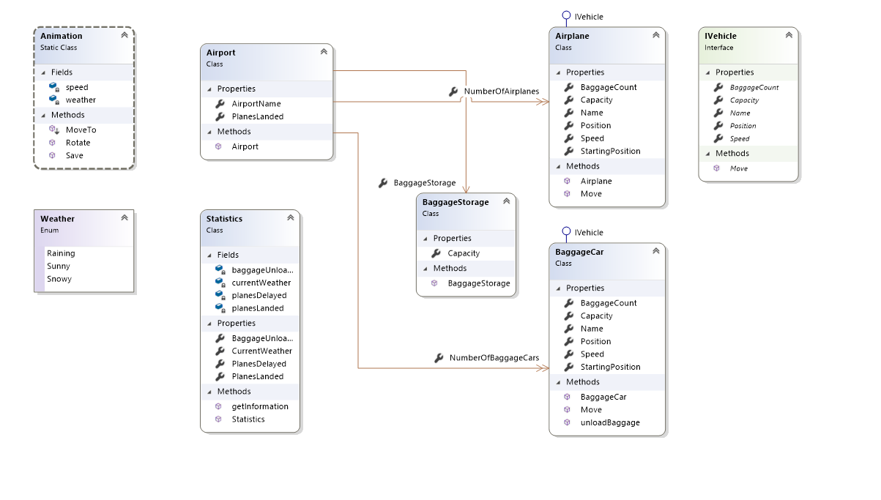

# **GUI**

# 

# **Milestones**

The whole duration of the project is divided into 2 main phases and each week a set of deliverables are required. At the end of the first phase the outcome should be all the documents we created and improved with the help of our tutor. Each software project starts with documentation part: how thing are viewed and how would be achieved. In the course of the second period we put all the ideas into the application itself and make it real. This step is more important as the end-product of the project is to show working version of the software solution we have created.

# **Timeline**

The amount of time we have to complete the second phase of the project is 8-9 weeks. During that time numerous test should have been carried to test the performance and how reluctant is the app is to bugs. Our group will have regular meetings in order to examine the behavior of the application and make it more reliable.

**Sequence Diagrams**

Load Diagram:

Save Diagram:

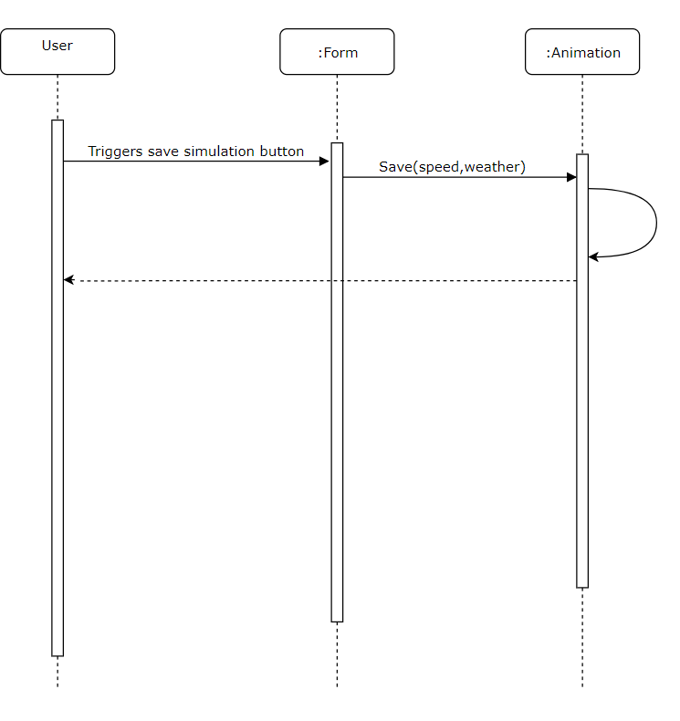

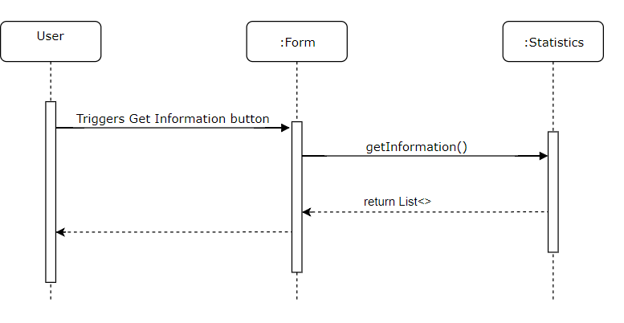Get Statistics Diagram: